**Step-By-Step Instructions:**

**Submit your 2025 Clare Boothe Luce Program Proposal**

Thank you for your interest in the Clare Boothe Luce Program! These instructions will take you **step-by-step** through the process of completing and submitting your 2025 Clare Boothe Luce Program Invited Institution Competition Information Form application.

Please keep these instructions handy as you progress through the application process.

**Preliminary Steps - Website Review and Registration**

**Step 1: Review the CBL Program Website and Linked Documents**

Please **thoroughly** review all of the information on the Clare Boothe Luce program webpages, including linked documents.

**Step 2: Register for an Account**

You can begin a CBL information form by clicking the “Apply for a Grant” button in the top left-hand portion of the Henry Luce Foundation website:

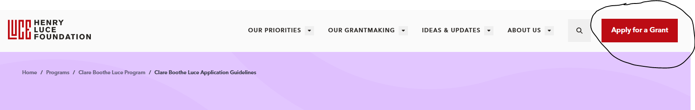

**NOTE**: If you already have a Luce Foundation account, you will be taken to the login page. Please skip to Step 5.

Applicants who are new to our system will be taken to the new user registration page. Click New User and enter your information:

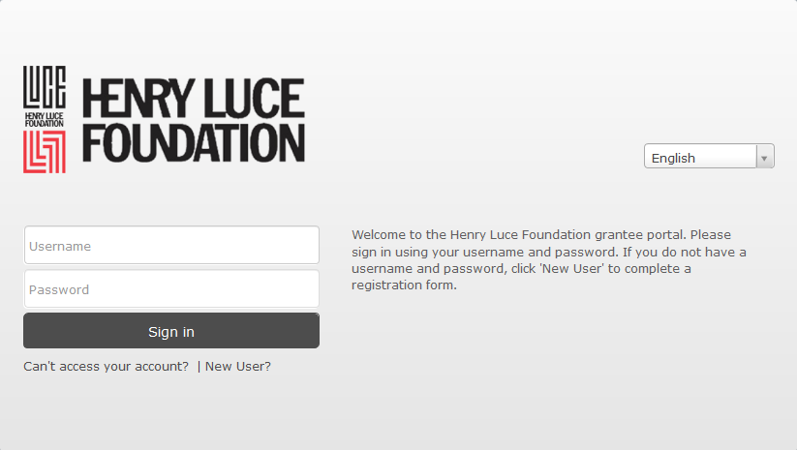

During this step, you will also be asked to identify your organization as part of the registration process (**Institution Search Menu** shown below).

**NOTE**: If you cannot find your organization, you may add it by clicking “Can’t find your organization”.

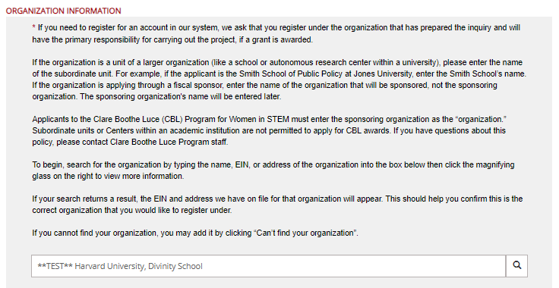

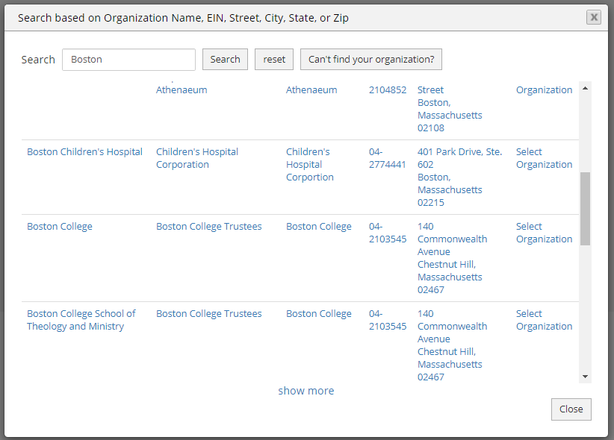

You will then be prompted to add your organization’s information to HLF’s database. Please enter all of the required fields and hit SAVE when you are done.

**NOTE**: Please see the brief instruction above the SAVE button, which states, “After saving, you will be directed back to the registration page. Please type your newly created organization into the text box and select it when it appears.

Once you have selected your organization, additional fields will appear and auto populate with address and EIN information. Please complete the fields under “Contact Information” and click “Submit” when you are done.

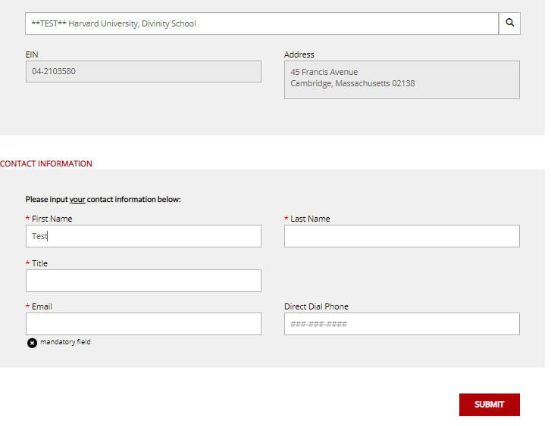

### **Step 3: Verify your email address** – once you have submitted your registration, you will see the below notification on your web browser, prompting you to check your email. You should receive an email verification request email from the Henry Luce Foundation Grants Portal Administration.

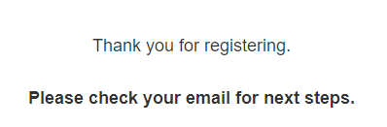

**Step 4: Activate Your Registration** – once you receive the registration request email, click the link in the email to create a password for your account. Once a password is set, you should immediately be able to login. (If you don’t receive this email soon after you register, please check your spam/junk folder.)

**Step 5: Log into your account:**

* Existing users please sign in using the login portal page imaged below.



**IMPORTANT ALERTS:**

* After each session, please logout of your account.
* If you have already worked on and saved a CBL Information Form, please see Page 7 of these instructions for information on how to access your “In Progress” Information Form through the Grantee Dashboard.

N**avigating the Information Form Application within the CBL Program Portal**

The very first time you log into the 2024 competition portal, you will be taken to the general Henry Luce Foundation application landing page. At the top of the page, you will find the “Clare Boothe Luce Applicants” tab. Click there to access the Clare Boothe Luce Program portal.

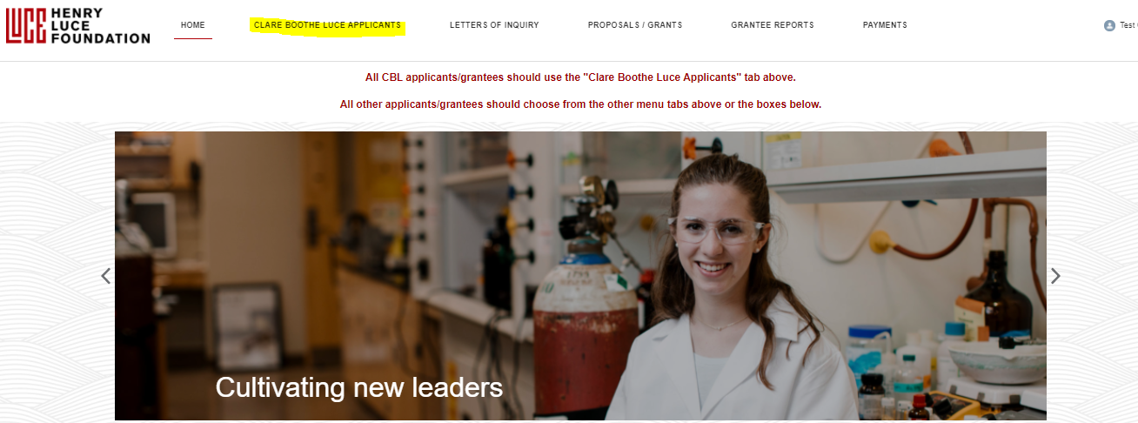

* You will then be taken to the Clare Boothe Luce Application page, where you can begin a new Information Form.
* There are three tabs in RED at the top of the screen. In order to complete the Form, please be sure you are in the “Information Form” tab.
* To start a new Information Form, navigate to the “**CBL INFORMATION FORM**” box located on the left-hand side of your screen, and click the “Begin New CBL Information Form” button.
* If you have already started an Information Form and are returning to work on it, your in- progress Form will appear under “Open CBL Information Forms.”

* Once you have selected, “Begin New CBL Information Form”, you will be redirected to the Information Form landing page, where you can check the “Portal Opens” date and “Submission Deadline” for applications for your records. When ready, please click “Start a New Info Form”.

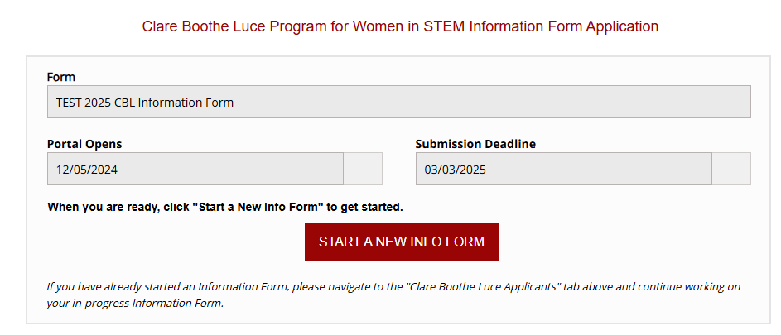

You will then be taken to the Information Form to complete. Applicants will be asked, on a single page, to download the form (if you didn’t already download a copy on the CBL website), complete information on their organization and contacts, and upload a Word or PDF copy of the information form. Please be sure to fill out all of the fields with an *. Please hit Text
when you are finished with the form and ready to upload.

**NOTE**: You will NOT be able to edit or revise the application once it’s been submitted.

You will receive a confirmation email once the application has been submitted.

**Submission Deadline:** The 2025 Information Form must be submitted through the online portal no later than **5:00pm in your time zone on March 3, 2025**.

**Thank you for your interest in the Clare Boothe Luce Program! We wish you all the best in the Invited Institution Competition.**

**QUESTIONS or PROBLEMS?**

For general information or questions about the CBL program and/or the application process, please thoroughly review all of the information available on our website, including linked program documents, FAQs, and these instructions.

If you have technical problems, please first make sure that is not due to an issue on your end (e.g., your institution’s firewall). If things check out on your end, please contact us about any issues you are having with the portal/Information Form as soon as possible.

For technical questions about the portal, please contact:

Mina Camacho, Grants Administrator, mina@hluce.org

For all other program related questions, please contact:

Dr. Aida Gureghian, Director of Leadership Programs

[Sarah](mailto:Sarah) DeMartazzi, Program Manager

Molly Sullivan, Program Assistant

at [WomenInSTEM@hluce.org](mailto:WomenInSTEM@hluce.org)